Java SE Project

Training And Placement Application

***PtViewAllCompletedJobsFrame Documentation***

1. **PtViewAllCompletedJobsFrame -**

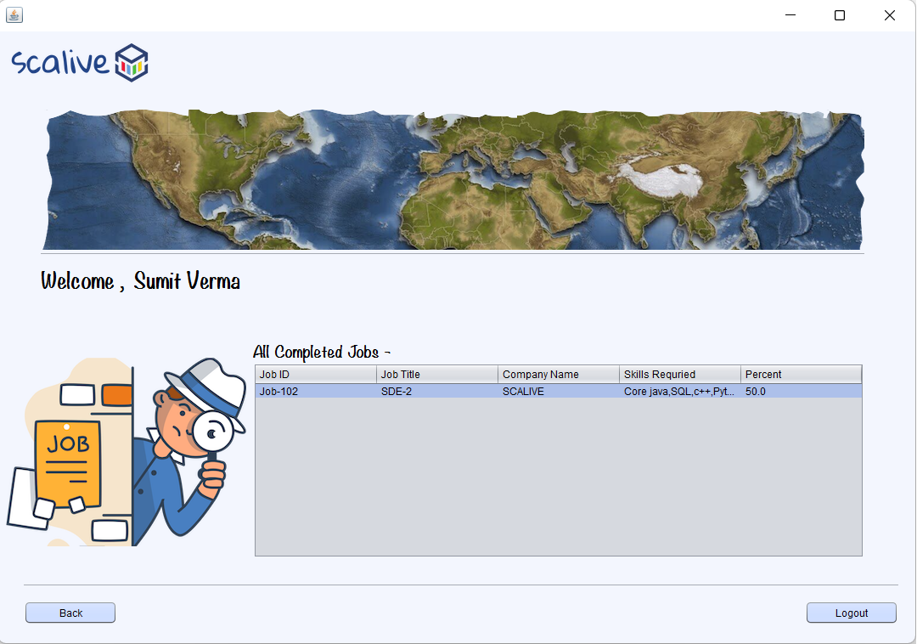

**WRITING THE CODE IN ResultDAO**

**Returning All Completed Jobs**

**public static List<ParticipantResultPojo> getAllCompletedJobs(String participantId)throws SQLException**

**The Code For getAllCompletedJobs()**

**public static List<ParticipantResultPojo> getAllCompletedJobs(String participantId)throws SQLException {**

**Connection conn=DBConnection.getConnection();**

**PreparedStatement ps=conn.prepareStatement("select jobs.jobid,jobtitle,companyname,tags,percentage from jobs,hr,results where results.jobid=jobs.jobid and jobs.hrid=hr.hrid and participantId=? and percentage!=-1 order by jobid ");**

**ps.setString(1, participantId);**

**ResultSet rs=ps.executeQuery();**

**List<ParticipantResultPojo> allResultList=new ArrayList<>();**

**while(rs.next()){**

**ParticipantResultPojo obj=new ParticipantResultPojo();**

**obj.setJobId(rs.getString(1));**

**obj.setJobTitle(rs.getString(2));**

**obj.setCompanyName(rs.getString(3));**

**obj.setTags(rs.getString(4));**

**obj.setPercentage(rs.getDouble(5));**

**allResultList.add(obj);**

**}**

**return allResultList;**

**}**

**The Code For PtViewAllCompletedJobsFrame**

**public class PtAllCompletedJobFrame extends javax.swing.JFrame {**

**private DefaultTableModel model;**

**private List<ParticipantResultPojo> allResultList;**

**public PtAllCompletedJobFrame() {**

**initComponents();**

**this.setLocationRelativeTo(null);**

**lblName.setText(CurrentUser.name);**

**model=(DefaultTableModel)tblAllJobs.getModel();**

**loadResultDetails();**

**}**

**void loadResultDetails()**

**{**

**try{**

**allResultList=ResultDAO.getAllCompletedJobs(CurrentUser.getId());**

**for(ParticipantResultPojo result:allResultList){**

**Vector<String> row=new Vector<>();**

**row.add(result.getJobId());**

**row.add(result.getJobTitle());**

**row.add(result.getCompanyName());**

**row.add(result.getTags());**

**row.add(String.valueOf(result.getPercentage()));**

**model.addRow(row);**

**}**

**if(allResultList.isEmpty()){**

**JOptionPane.showMessageDialog(null,"No Quiz Taken", "Job Not Found!",JOptionPane.INFORMATION_MESSAGE);**

**}**

**}**

**catch(SQLException ex){**

**JOptionPane.showMessageDialog(null,"DB Error In Quiz", "Error!!",JOptionPane.ERROR_MESSAGE);**

**ex.printStackTrace();**

**}**

**}**